BUSINESS INTELLIGENCE LAB
EXPERIMENT 7
Integration of Advanced Analytics with BI Reports using Microsoft Power BI

1. Aim
To integrate advanced analytics with Business Intelligence reports using Microsoft Power BI, analyse organizational performance through key performance indicators and comparative visuals, identify business strengths, weaknesses and opportunities, and develop data-driven recommendations for decision-making.

2. Learning Objectives
- Review and interpret the existing Power BI report pages prepared for advanced business analysis.
- Analyse sales performance across regions, product categories and customer segments.
- Examine monthly and yearly sales movement and profit-margin patterns.
- Investigate profit drivers, discount bands, loss indicators and customer-segment margins.
- Identify business strengths, weaknesses and opportunities using report evidence.
- Communicate analytical findings through a Business Insight Report and executive presentation.

3. Software and Requirements
- Microsoft Power BI Desktop.
- The supplied Experiment7.pbix report.
- Microsoft Word for preparing the Business Insight Report.
- Microsoft PowerPoint for preparing the executive presentation.
- Underlying business data and model embedded or referenced by the supplied PBIX report.

4. Introduction / Theory
Business Intelligence (BI) converts business data into meaningful information that supports monitoring, analysis and decision-making. Basic reports present totals and summaries, while advanced analytics examines relationships, trends, comparisons and possible causes of performance differences. A well-designed BI report combines key performance indicators (KPIs), charts, tables and filters so that users can move from an overall view to a more focused investigation.
Power BI supports this analysis through Card visuals, bar and column charts, line charts, tables, slicers and other interactive report elements. KPI cards summarize measures such as sales, profit, order volume and profit margin. Comparative charts help identify differences among regions, categories, sub-categories and customer segments. Time-based visuals show changes across months and years. Discount analysis can help managers investigate whether different discount levels are associated with changes in profit.
In this experiment, the supplied Experiment 7 PBIX report is organized into four pages: Executive Dashboard, Growth & Margin, Profit Drivers, and Discounts & Segments. Together, these pages provide a multi-dimensional view of business performance. The report is intended to support the identification of business issues and the preparation of recommendations. Specific numerical findings must be taken from the live report after it is opened and filtered; no unverified figures are assumed in this document.

5. Part 1: Overview of the Power BI Report
The supplied Experiment 7 PBIX contains four report pages. The pages group the analysis into executive-level monitoring, time-based growth and margin analysis, profit-driver analysis, and discount/customer-segment analysis.
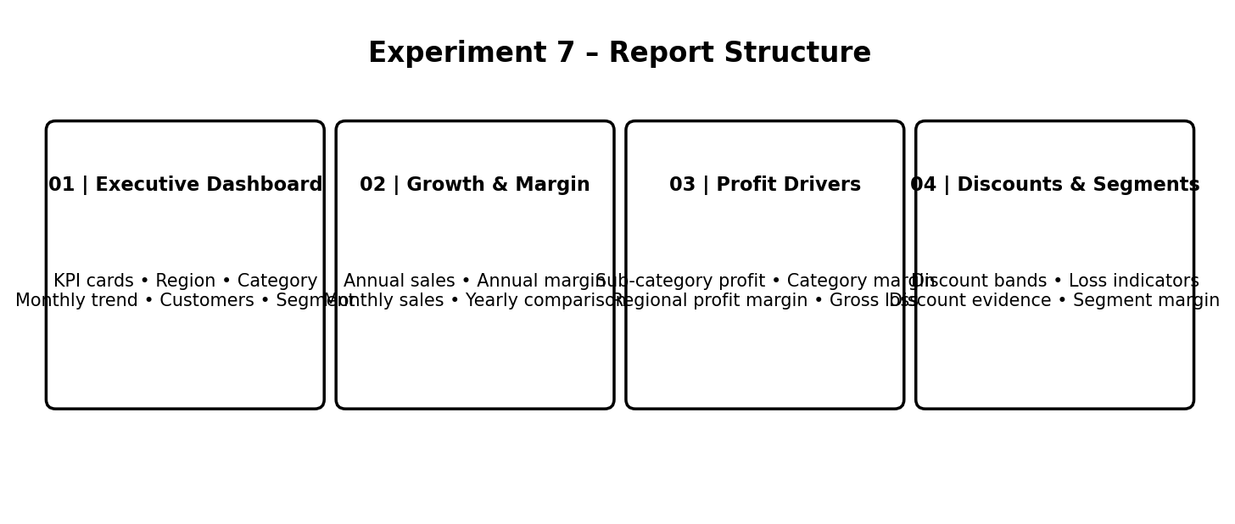
Figure 1. Overview of the four report pages in the supplied Experiment 7 PBIX.
Report page | Main analytical components | Purpose
01 | Executive Dashboard | Total Sales, Total Profit, Total Orders and Profit Margin KPI cards; sales by region and category; monthly sales trend; top customers by sales; profit by segment; scorecard; Region, Category and Year filters. | Provides a consolidated view of overall performance and supports focused exploration.
02 | Growth & Margin | Annual sales, annual profit margin, monthly sales and yearly comparison, with KPI cards and filters. | Examines time-based sales movement and whether profitability changes alongside sales.
03 | Profit Drivers | Profit by sub-category, profit margin by category, regional profit margins and gross-loss indicators. | Investigates the product and regional areas associated with profit performance.
04 | Discounts & Segments | Average discount, loss lines, loss-line share, gross loss, net profit by discount band, sales by discount band, discount evidence and customer-segment margin. | Explores discount patterns, loss indicators and margin differences among customer segments.

6. Part 2: Executive Dashboard

6.1 KPI Cards
The Executive Dashboard includes KPI cards for Total Sales, Total Profit, Total Orders and Profit Margin. These cards provide a quick summary of performance in the current filter context. Total Sales represents sales value, Total Profit represents profit, Total Orders indicates order volume, and Profit Margin expresses profit relative to sales as a percentage.
The four KPIs should be interpreted together. An increase in sales does not automatically mean that profitability has improved. Comparing Total Profit and Profit Margin with Total Sales provides a more balanced view of business performance.

6.2 Sales by Region
The regional sales visual compares sales contribution across the available regions. It helps identify differences in sales performance and provides a starting point for further investigation. Regional sales should be considered alongside regional profit margins on the Profit Drivers page before drawing conclusions about overall regional performance.

6.3 Sales by Category
The category sales visual compares sales across product categories. It helps identify the categories contributing to revenue. Category sales should be compared with the profit-margin analysis on the Profit Drivers page because a category with high sales may not necessarily have the strongest margin.

6.4 Monthly Sales Trend
The monthly sales trend presents sales movement over time. It can be used to identify periods of higher or lower sales, recurring patterns and changes that may require additional investigation. The actual trend should be read from the visual after opening the report.

6.5 Top 10 Customers by Sales
The Top 10 Customers by Sales visual ranks customers according to sales contribution. It helps focus attention on major customers. Sales ranking alone does not establish customer profitability; it should be interpreted together with available segment-margin and profit information.

6.6 Profit by Segment and Scorecard
Profit by Segment compares profit contribution across customer segments. The scorecard provides a compact performance-monitoring view. The scorecard target is described in the report as illustrative (previous-year performance plus 10%); it should not be represented as an official company target unless independently confirmed.

7. Part 3: Growth and Margin Analysis

7.1 Annual Sales
The annual sales visual supports comparison of sales across years. It helps identify changes in business scale over time. Users should note the years displayed and compare the values using the same filter selections.

7.2 Annual Profit Margin
The annual profit-margin visual complements annual sales by showing how profitability changes over time. Comparing the two measures helps determine whether sales growth is accompanied by stronger margins or whether the margin pattern differs.

7.3 Monthly Sales and Yearly Comparison
The monthly sales visual provides a more detailed time-based view, while the yearly comparison presents a summary across years. Together, they help investigate short-term variation and longer-term movement. The selected Region and Category filters should be kept consistent when comparing these visuals.

8. Part 4: Profit Drivers

8.1 Profit by Sub-category
The profit-by-sub-category visual breaks product performance into more detailed product groups. It can reveal differences that may be hidden when results are summarized only at the category level. Sub-categories with relatively low or negative profit should be investigated further.

8.2 Profit Margin by Category
Profit margin by category allows comparison of profitability relative to sales. This is important because a category may generate high revenue but retain a smaller proportion of that revenue as profit. The visual supports a more balanced evaluation of category performance.

8.3 Regional Profit Margins and Gross Loss
Regional profit margins allow comparison of profitability across regions. The gross-loss KPI provides an additional indicator of loss exposure. These measures can be used to identify where further investigation may be necessary, but the report values should be checked before naming a specific region or category as the weakest performer.

9. Part 5: Discounts and Customer Segments

9.1 Average Discount and Loss Indicators
The page includes Average Discount, Loss Lines, Loss Line Share and Gross Loss indicators. These measures provide context for understanding the scale of discounting and the presence of loss-making lines. They help identify areas for investigation rather than proving that discounts alone caused a loss.

9.2 Net Profit by Discount Band
The net-profit-by-discount-band visual compares profitability across discount ranges. It can help management examine whether profit differs between discount levels. The relationship should be interpreted carefully because product mix, customer type, region and other factors may also influence profit.

9.3 Sales by Discount Band and Discount Evidence
Sales by discount band shows how sales are distributed across discount ranges. The Discount Evidence table provides supporting detail for closer review. Comparing sales and net profit by discount band helps avoid treating high sales volume as the only measure of success.

9.4 Customer Segment Margin
Customer Segment Margin compares profitability across customer segments. It complements the Profit by Segment visual on the Executive Dashboard by focusing on margin rather than profit amount alone. The two views together help distinguish sales/profit contribution from relative profitability.

10. Part 6: Interpretation and Business Use
The four pages work together as a sequence. The Executive Dashboard gives management a high-level overview. Growth & Margin examines performance over time. Profit Drivers investigates differences among sub-categories, categories and regions. Discounts & Segments adds context about discount patterns, loss indicators and customer-segment margins.
A manager can begin with the KPI cards, identify an area that requires attention, and then use the relevant analytical page to investigate it. For example, a category with high sales but a comparatively low profit margin can be examined using the category-margin and sub-category-profit visuals. A region with lower margin can be investigated using the regional profit-margin visual. Discount-band analysis can then help examine whether profit differs across discount levels.

11. Business Strengths, Weaknesses and Opportunities
The PBIX report provides the analytical views needed to assess business performance. The actual strengths, weaknesses and opportunities must be written after reviewing the displayed values. The following table gives a structure for recording evidence without assuming results that are not visible in the report definition.
Analysis area | Evidence to review | How to record the finding
Business strengths | Relatively strong sales, profit, profit margin, customer contribution or positive time-based movement. | Name the region/category/segment/time period and quote the value or comparison shown in Power BI.
Business weaknesses | Low or negative profit, weak margin, loss lines, gross loss, or sales growth that is not matched by margin improvement. | Identify the affected area and cite the relevant KPI, chart or table value.
Business opportunities | Areas where margin, product mix, regional focus, customer strategy or discount policy may be improved. | Describe the opportunity and connect it to the observed evidence.

12. Recommendations
Recommendations should be based on the findings confirmed in the live dashboard. The following are suitable recommendation areas; select and tailor them only where the report evidence supports them.
- Review discount levels and approval practices in discount bands where net profit or loss indicators suggest a margin concern.
- Examine sub-categories with comparatively low or negative profit to understand their product mix, pricing and cost drivers.
- Compare regional sales with regional profit margins before deciding where to expand sales or allocate resources.
- Prioritize customer-retention and service strategies using both customer contribution and segment-margin evidence.
- Use monthly and annual sales trends to support demand planning, inventory planning and promotional scheduling.
- Monitor Total Sales, Total Profit, Total Orders and Profit Margin together rather than relying on sales growth alone.

13. Summary Table
Report component | Key measures / fields | Business purpose
Executive KPI cards | Total Sales, Total Profit, Total Orders, Profit Margin | Monitor overall business performance.
Regional sales | Region, Sales | Compare revenue contribution by region.
Category sales | Category, Sales | Compare revenue contribution by product category.
Monthly sales trend | Month, Sales | Review monthly movement and possible recurring patterns.
Top 10 customers | Customer Name, Sales | Identify major customer sales contributors.
Profit by segment | Segment, Profit | Compare profit contribution across customer segments.
Growth & Margin | Annual Sales, Annual Profit Margin, Monthly Sales, Yearly Comparison | Evaluate changes in sales and profitability over time.
Profit Drivers | Profit by Sub-category, Profit Margin by Category, Regional Profit Margins, Gross Loss | Investigate the sources of profit and loss.
Discounts & Segments | Average Discount, Loss Lines, Loss Line Share, Gross Loss, Net Profit by Discount Band, Sales by Discount Band, Customer Segment Margin | Examine discount-related patterns and customer-segment profitability.
Interactive filters | Region, Category, Year | Focus analysis on selected business dimensions.

14. Result
The supplied Experiment 7 Power BI report was reviewed as an advanced analytics dashboard containing four pages: Executive Dashboard, Growth & Margin, Profit Drivers, and Discounts & Segments. The report structure provides KPI monitoring, regional and category comparisons, customer and segment analysis, monthly and yearly trends, profit-driver analysis, and discount-related indicators. These views support the identification of business strengths, weaknesses, opportunities and data-driven recommendations.

15. Conclusion
This experiment demonstrates how advanced analytics can extend traditional Business Intelligence reporting. By combining KPI cards, comparative visuals, time-based analysis, profit-driver views, discount analysis and customer-segment margins, Power BI provides a structured way to investigate business performance. The Executive Dashboard supports a quick overview, while the other report pages provide deeper analysis. The final business conclusions depend on the actual values displayed in the report after applying the relevant filters.

16. Submission Checklist
- Confirm that all four Experiment 7 report pages open and display values.
- Check Total Sales, Total Profit, Total Orders and Profit Margin KPI cards.
- Review regional sales and category sales visuals.
- Review monthly and annual sales and profit-margin trends.
- Review profit by sub-category, category margin, regional margin and gross-loss indicators.
- Review discount-band visuals, loss indicators and customer-segment margin.
- Test Region, Category and Year filters and confirm that the relevant visuals respond.
- Insert screenshots from the live Power BI report in the final submission if required.
- Verify all numerical findings and recommendations against the actual report.

